A picture containing clipart

Description generated with very high confidence

Azure 103 Module 2

Hands On - 13

Azure Certification Training

[**support@intellipaat.com**](mailto:support@intellipaat.com)

**+91-7022374614**

**US: 1-800-216-8930(Toll Free)**

**Azure 103 Module 2, Hands On – 13**

**Using Tables with Storage Explorer.**

**Step 1:** Open Azure Storage Explorer and Connect it to your Storage Account. If you don't know how to do it then take a look at our Azure Storage Explorer Hands On. 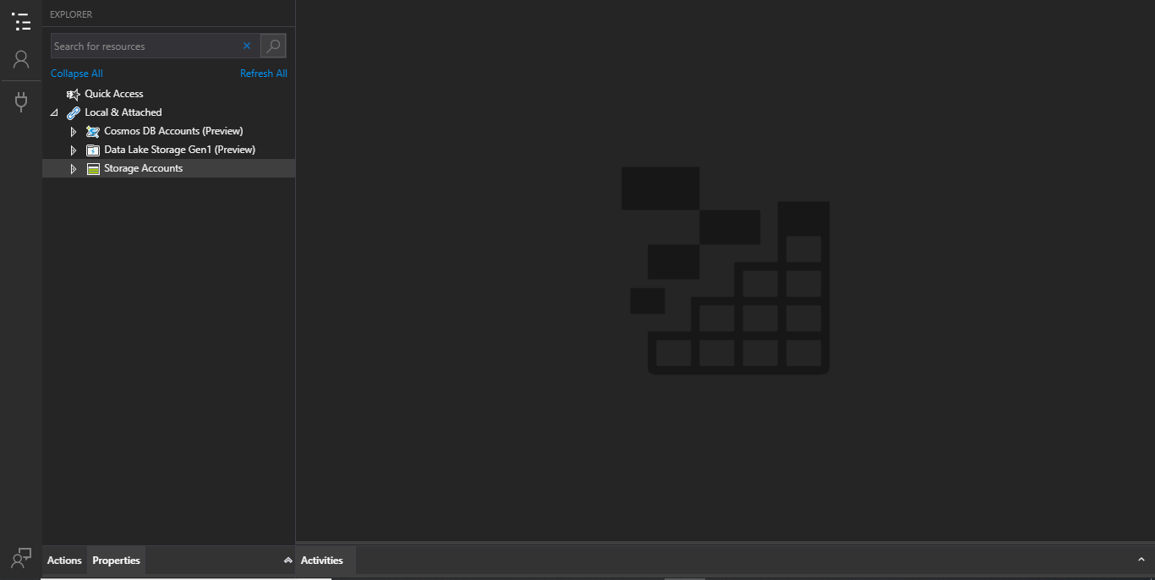

**Step 2:** Expand the storage account and tables.

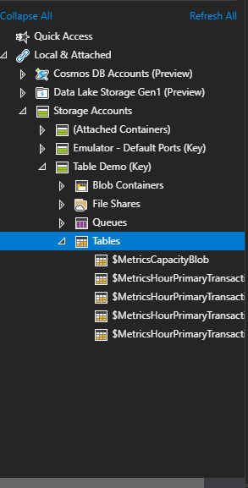

**Step 3:** Right Click on Tables.

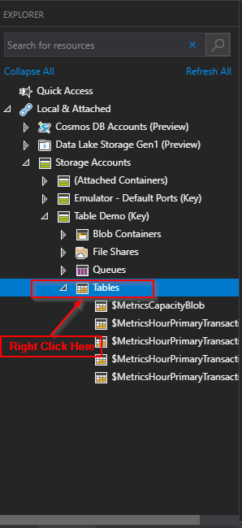

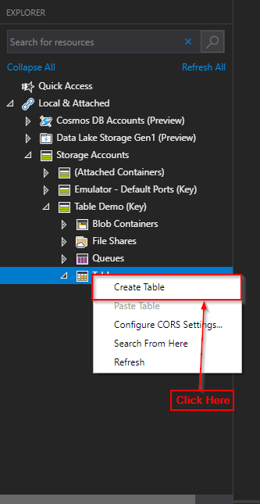**Step 4:** Click on create table.

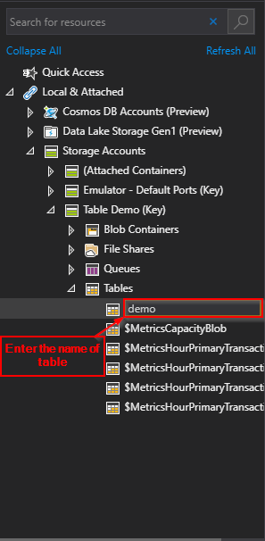**Step 5:** Give the table a name (e.g. demo).

**Add Data**

**Step 1:** Enter the following command: 'node sender.js', This will send messages into your queue in Azure.

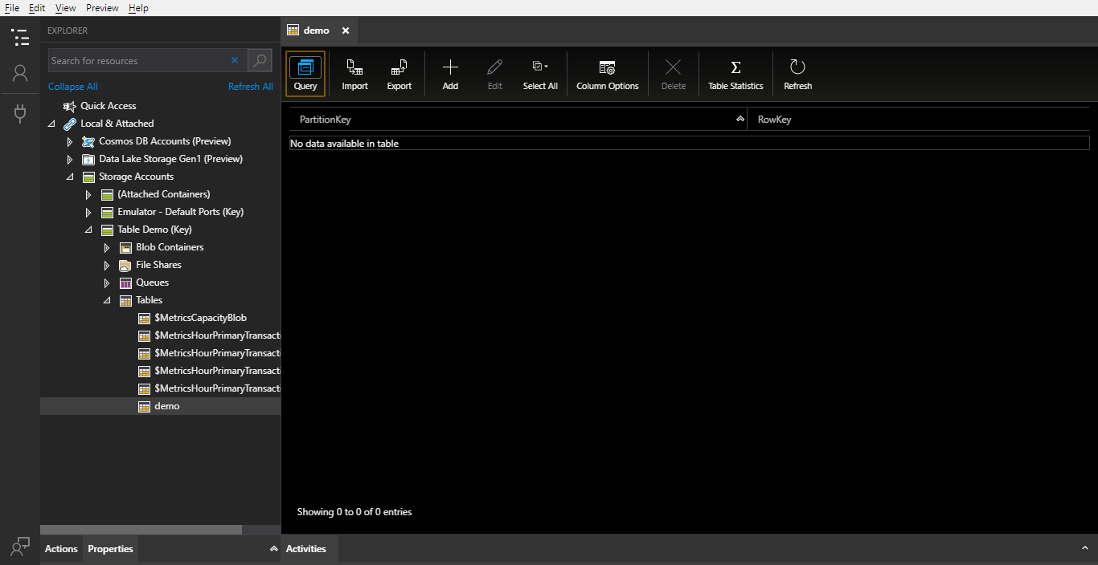

**Step 2:** Click on 'Add'.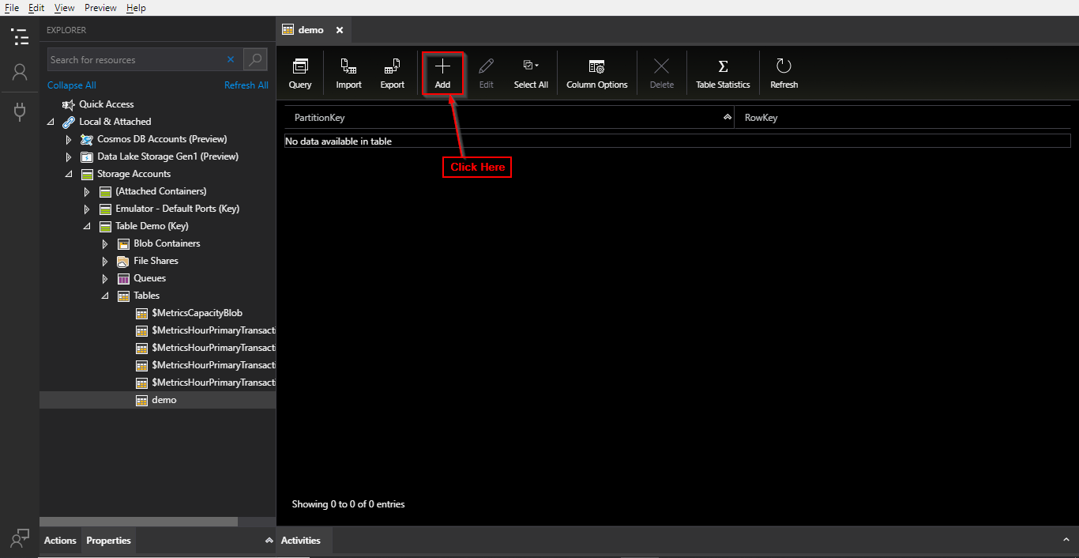

**Step 3:** Click on 'Add Property'.

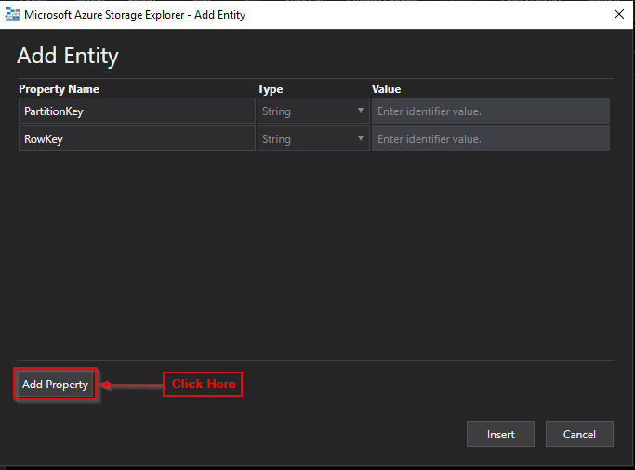

**Step 4:** Set PatitionKey and RowKey to '1', 'Property Name' to 'Email', 'Type' to 'String', 'Value' to a value you want and click on 'Insert'.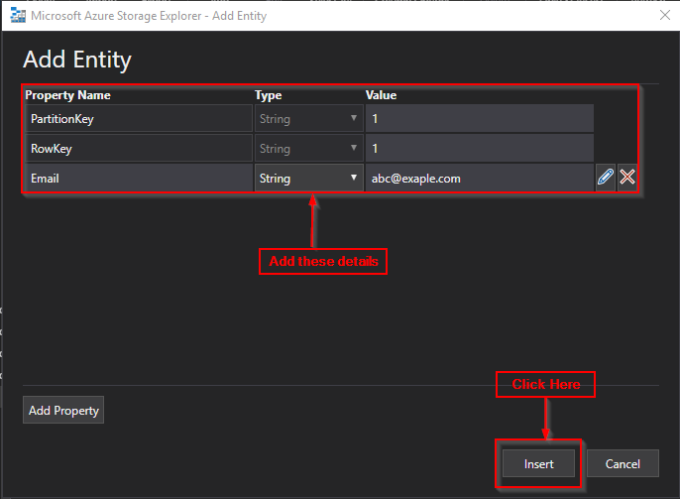

**Edit Data**

**Step 1:** Right Click on the row you wish to edit.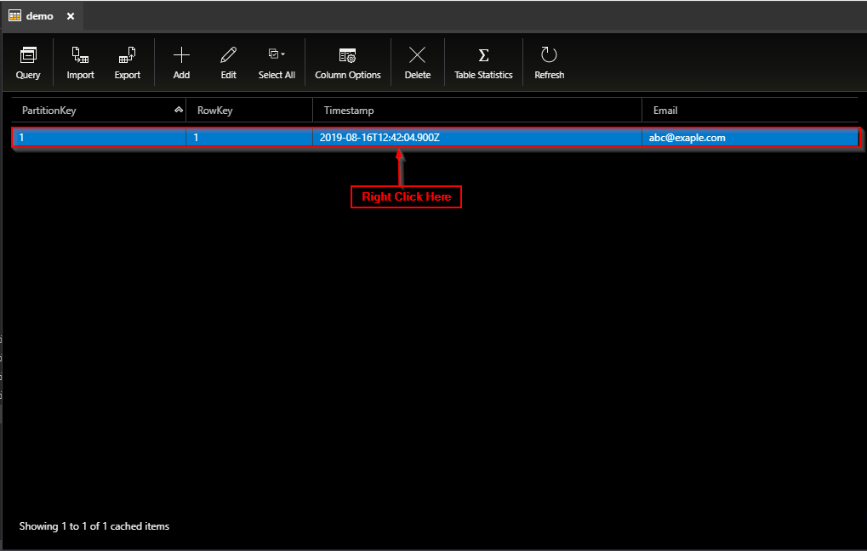

**Step 2:** Click on 'Edit'.

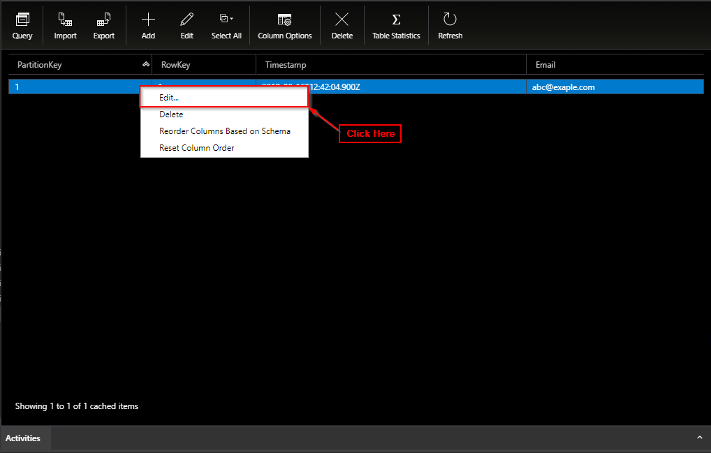

**Step 3:** Open the queues page and refresh it. You will notice that all the previously added messages are now gone.

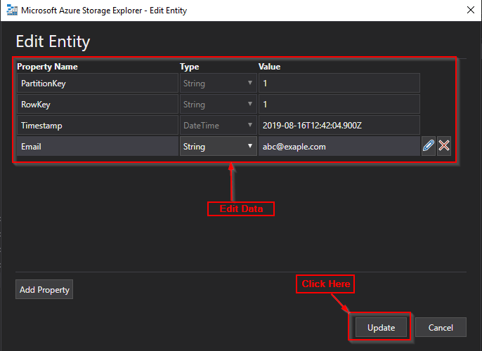

**Edit Data**

**Step 1:** Select all the rows you wish to delete.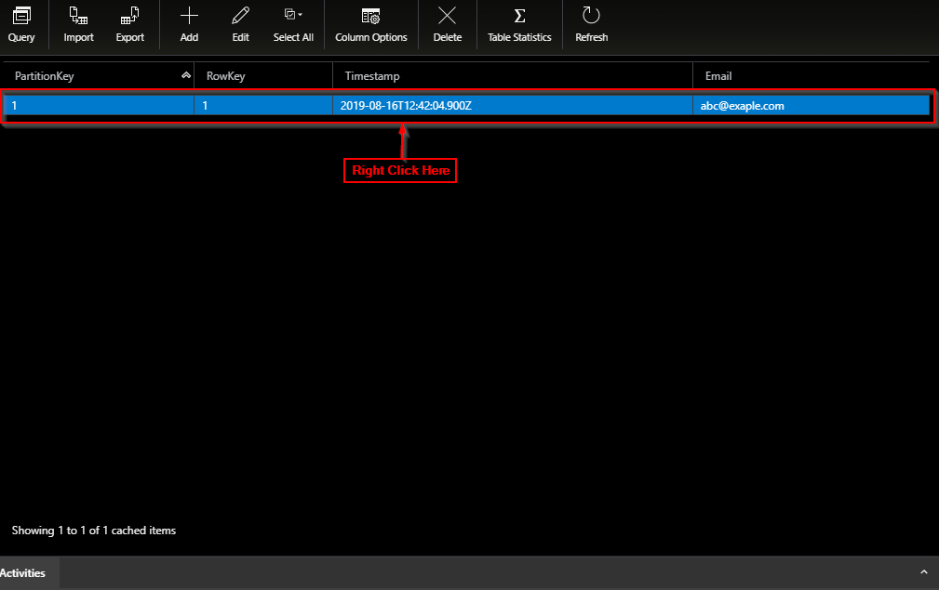

**Step 2:** Right Click on the row you wish to delete.

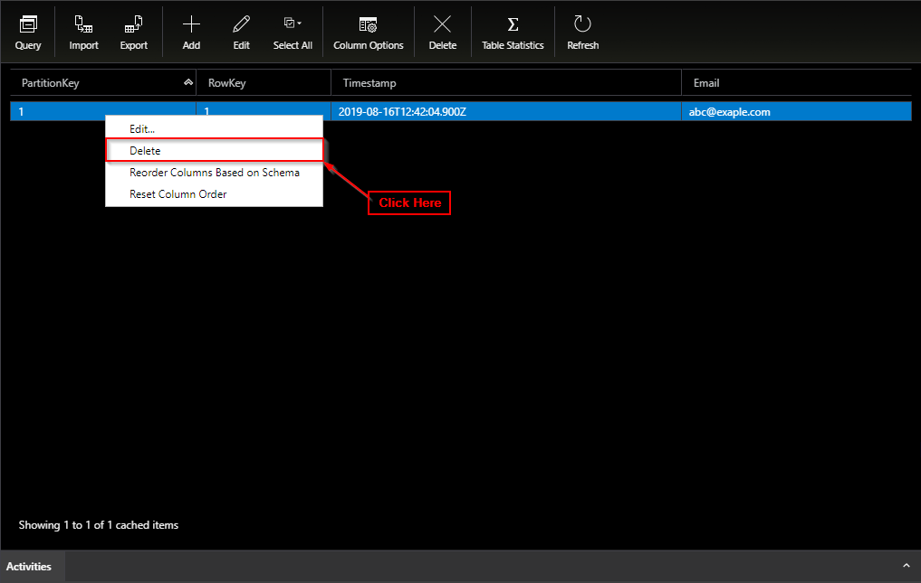

**Step 3:** Click on 'Yes'

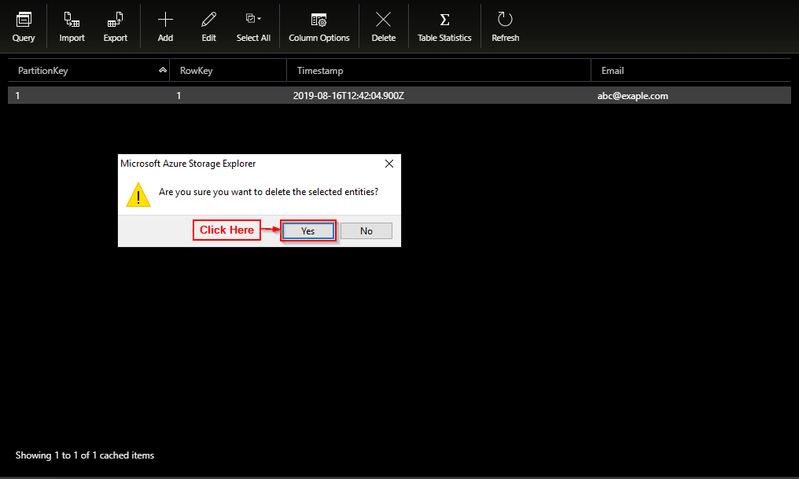

**Query Data**

**Step 1:** Click on Query.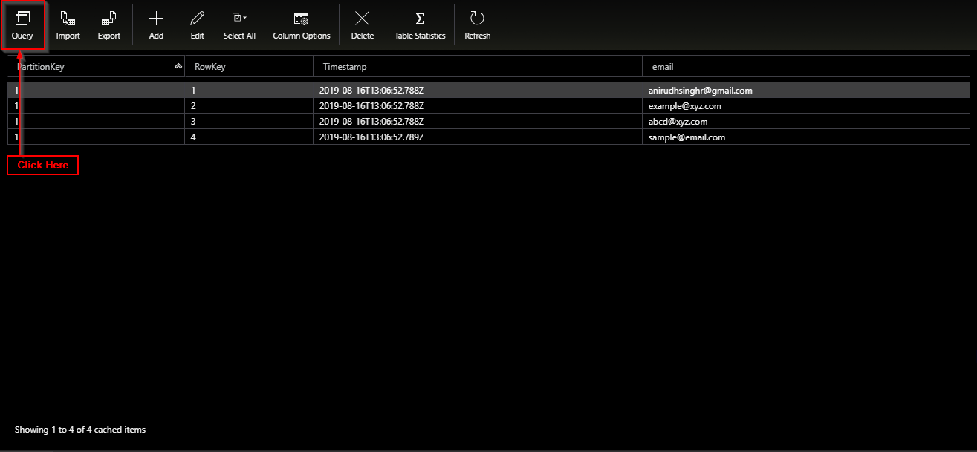

**Step 2:** Click on Add New Clause.

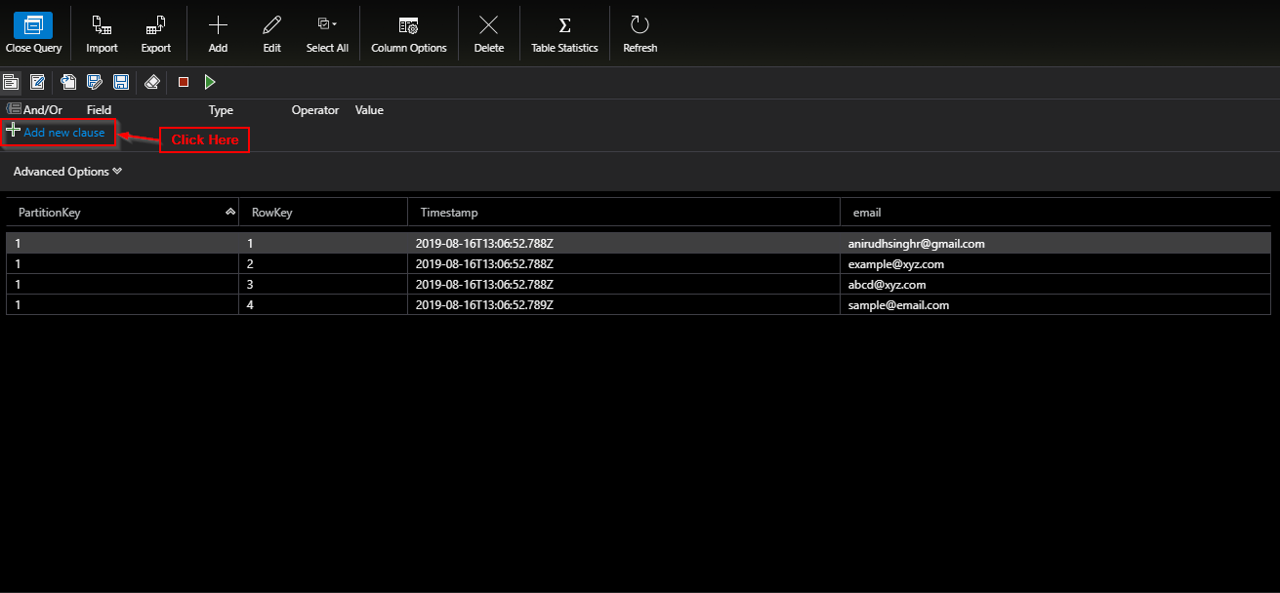

**Step 3:** Enter the 'Field', 'Type', 'Operator' and 'Value'.

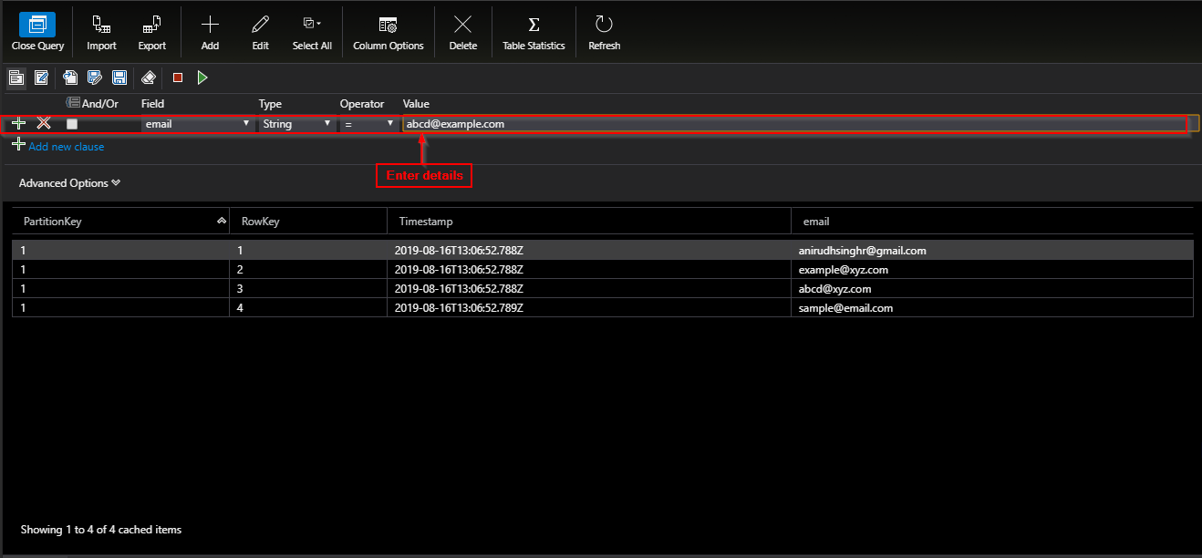

**Step 4:** Click on Execute Query (green play button).

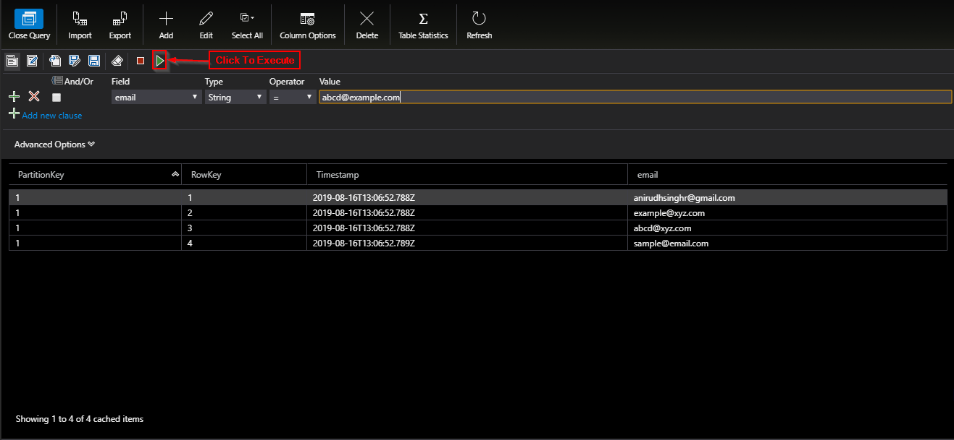

**Import Data**

**Step 1:** Create a CSV file with all the data you wish to import.

**Step 2:** Click on import.

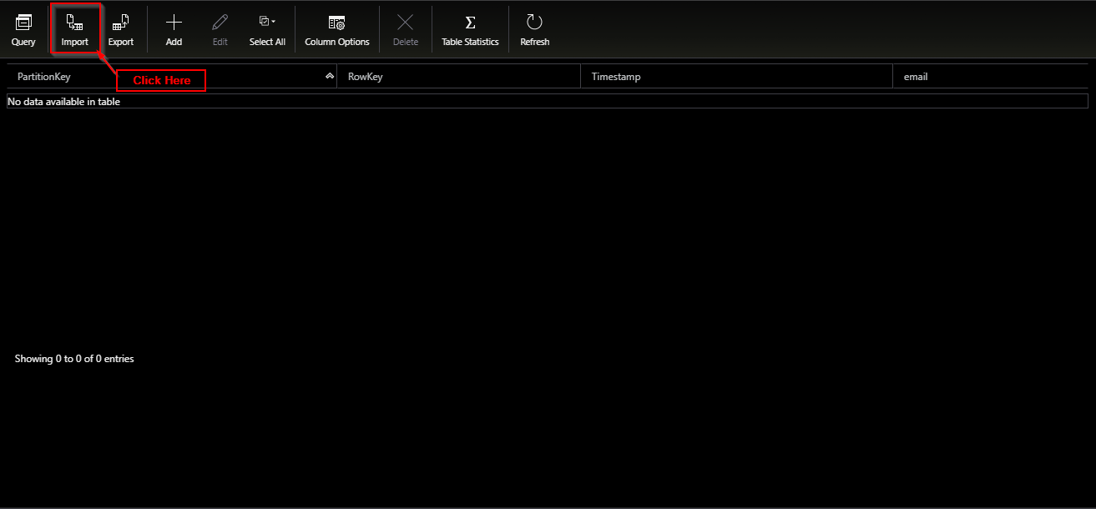

**Step 3:** Click on the file you wish to import and Click on Open.

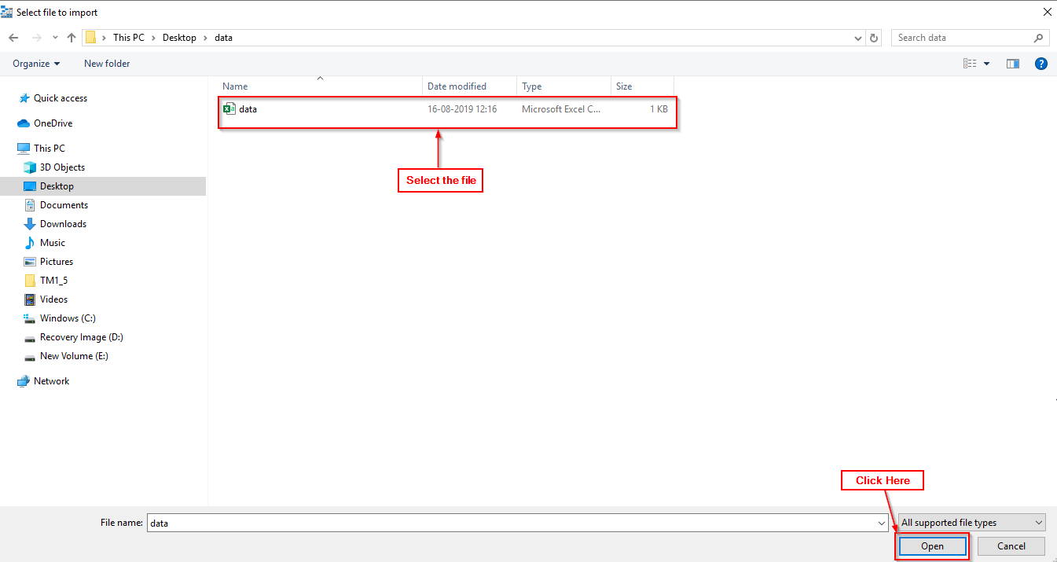

**Step 4:** Click on Insert.

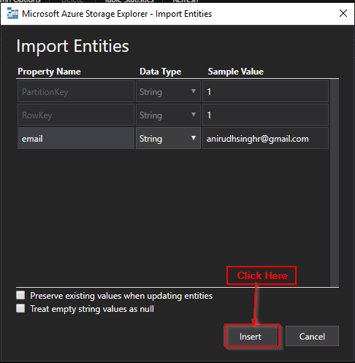

**Export Data**

**Step 1:** Click on the table you wish to Export.

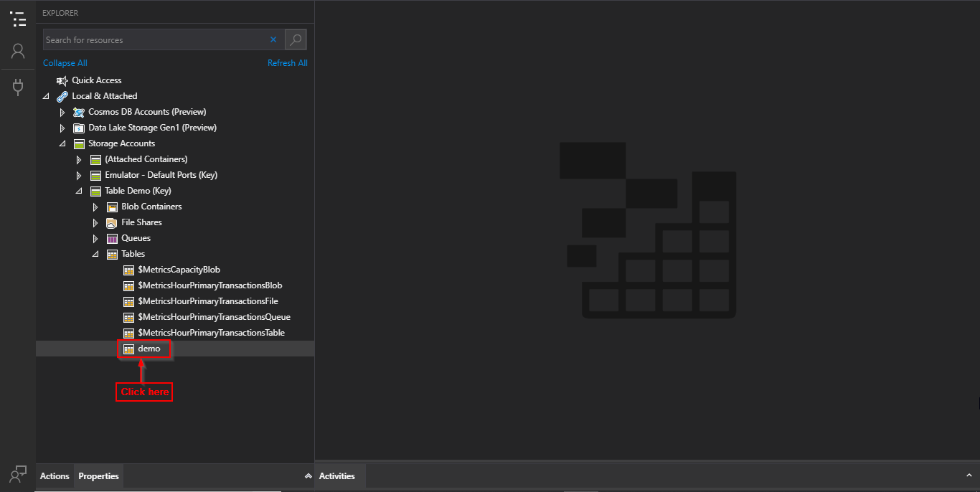

**Step 2:** Click on Export.

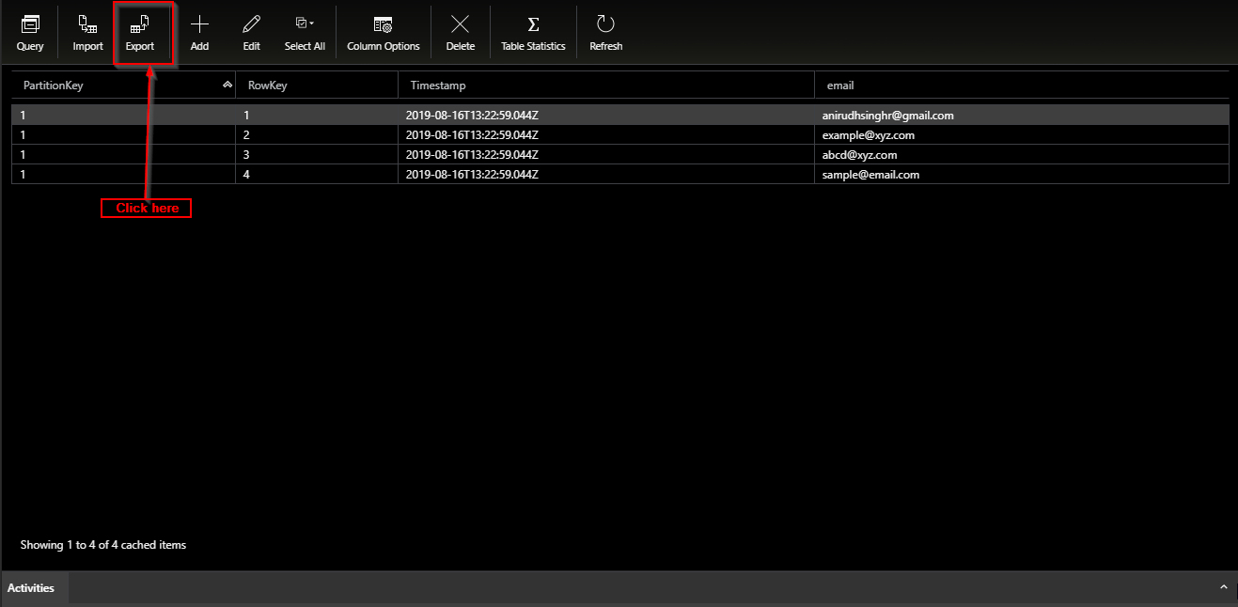

**Step 3:** Select File Type, Name and Click on Save.

